**Manual for balances**

How to change value of parameter in PowerSim!

1: Change value of constant in PowerSim

2: Run PowerSim model pressing play ( )

3: Save!

4: Open Excel and go to A1 in “sheet 1”.

5: Click on “data” and choose refresh

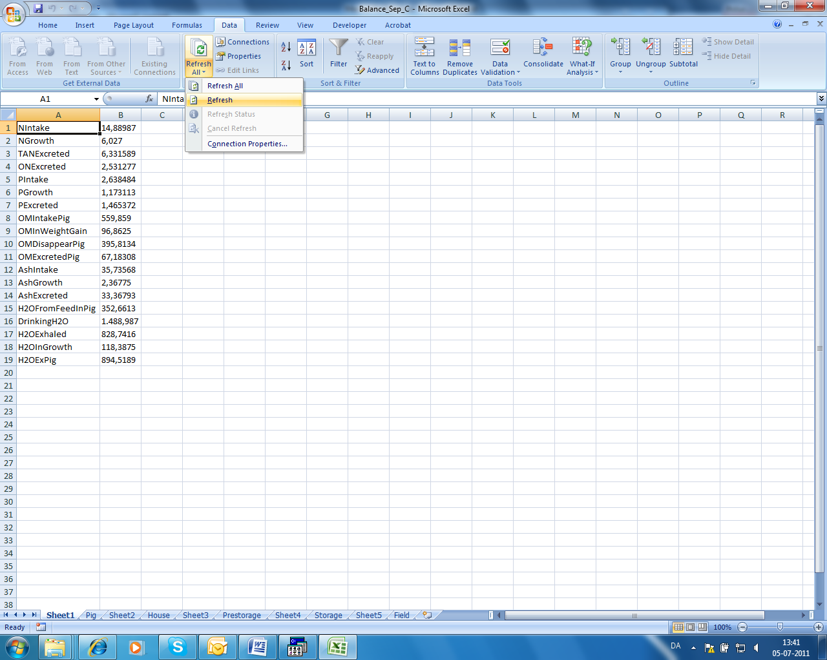

6: Choose the text fill corresponding to the spreadsheet (In this cause pig, see list below). And press import.

7: Check new balance in spreadsheet “pig”

7: Repeat 4 to 6 with every spreadsheet that has to be updated.

List of balances

|  |  |
| --- | --- |
| **Raw data** | **Balance** |
| Sheet 1 | Pig |
| Sheet 2 | House |
| Sheet 3 | Prestorage |
| Sheet 4 | Storage |
| Sheet 5 | Field |